Hair-cutting Day with Marilyn Crowe
- 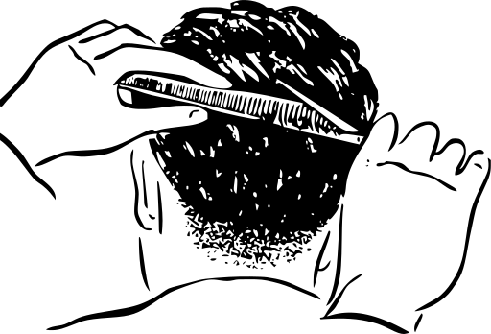
Marilyn Crowe will be at Health wing for haircuts and eyebrows-waxing
on
Friday October 17, 2025
10 am to 3 pm
Elders, band members, staff are welcome to come and attend.

We will have refreshments water, fruit, snacks. Please drop in or call Tracey to schedule a time.



